Daily Derivatives & Market Report
CONTENTS
Page No. | Particulars
2 | Market Summary
3 | Nifty Futures – Derivatives Snap
4 | Bank Nifty Futures – Derivatives Snap
5 | Activity in Nifty Options
6 | What do Nifty Technical suggest
7 | Disclaimer
Index Trend Analysis
Pivot(Daily) | Close | S2 | S1 | Pivot | R1 | R2 | Daily | Weekly | Monthly
Nifty | 11897 | 11782 | 11840 | 11894 | 11952 | 12006 | Buy | Buy | Buy
Sensex | 40544 | 40101 | 40323 | 40527 | 40749 | 40954 | Buy | Buy | Buy
Nifty Futures | 11895 | 11777 | 11836 | 11890 | 11950 | 12004 | Buy | Buy | Buy
Bank Nifty | 24312 | 23883 | 24097 | 24254 | 24469 | 24625 | Buy | Neutral | Sell
CNX IT | 21694 | 21173 | 21434 | 21607 | 21867 | 22040 | Buy | Buy | Buy
CNX Midcap | 17023 | 16763 | 16893 | 16966 | 17096 | 17168 | Buy | Neutral | Neutral
CNX Small Cap | 5904 | 5835 | 5870 | 5889 | 5924 | 5944 | Buy | Buy | Neutral

Market Summary
Domestic Indices | Close |  | Points | % Chg
SENSEX |  | 40544.37 | 112.77 | 0.28
NIFTY |  | 11896.80 | 23.75 | 0.20
MIDCAP |  | 14775.12 | 69.27 | 0.47
SMLCAP |  | 14896.14 | 45.26 | 0.30
BSEFMC |  | 11099.79 | -42.28 | -0.38
AUTO |  | 17855.68 | 50.26 | 0.28
POWER |  | 1613.38 | -15.62 | -0.96
REALTY |  | 1787.61 | 64.96 | 3.77
BSE IT |  | 22040.59 | 292.10 | 1.34
BANKEX |  | 27592.93 | 18.84 | 0.07
OILGAS |  | 11965.16 | -159.3 | -0.96
METAL |  | 8346.68 | 1.43 | 0.02

Currency Futures | Close | Pre. Pts | % Chg
27-Oct-20 USD-INR | 73.51 | 0.14 | 0.19
27-Oct-20 EUR-INR | 86.79 | 0.48 | 0.55
27-Oct-20 GBP-INR | 95.22 | -0.16 | -0.16
27-Oct-20 JPY- INR | 69.60 | -0.06 | -0.08

Advance/ Decline | Adv | Dec | Un Ch.
NSE | 975 | 878 | 120
BSE | 1326 | 1355 | 168

FII/DII Capital Mkt* | Buy | Sell | Net
DII | 2928 | 4561 | (1633)
FII | 6336 | 4751 | 1585

*NOTE: - FII AND DII data figure is provisional

Market Commentary
Markets made a negative start of the trading day, with Finance Minister Nirmala Sitharaman’s statement that the government has begun an exercise to assess the impact of the pandemic on the economy and likely contraction in GDP, even as she did not rule out the possibility of another stimulus to boost growth. But soon, indices turned positive, taking support with data released by the Ministry of Statistics and Programme Implementation (MoSPI) in the quarterly bulletin of the Periodic Labour Force Survey (PLFS) showing that unemployment in urban areas fell to 8.4% in July- September 2019 from 8.9% in the June quarter last year.
Markets remained higher for the almost whole day, as domestic sentiments were optimistic, as markets regulator SEBI allowed exchanges dealing with agri-commodity derivatives to utilise the fund created for farmers and FPOs for reimbursement of mandi tax and charges incurred by them on storage and transportation of goods. The decision was taken based on the recommendations of the CDAC. Some support also came after FM Nirmala Sitharaman exhorted large CPSEs to achieve by December 75 per cent of their planned capital expenditure (capex) target for 2020-21, to support economic growth hit by the COVID-19 crisis.
On the global front, European markets were trading mostly in green as strong earnings from Swiss bank UBS, consumer giant Reckitt Benckiser and others offset concerns from tighter coronavirus curbs across the continent and doubts over fresh U.S.stimulus. Asian markets ended mostly lower on Tuesday, after China's central bank left its benchmark lending rates unchanged for the sixth consecutive month after the official data revealed that the economic growth gained further momentum in the third quarter. The one-year loan prime rate was retained at 3.85 percent and the five-year loan prime rate was maintained at 4.65 percent.

Market Turnover & FII Derivative Data
Market TO | Current | Previous | Net%
BSE CASH | 2331 | 2237 | 4
NSE CASH | 47641 | 48510 | (2)
NSE FO | 1685767 | 1635134 | 3

FII Derivatives | Buy | Sell | Net
Ind. Futures | 3142.03 | 3426.59 | (285)
Ind. Options | 176210 | 174436 | (1067)
Stk. Futures | 21653 | 21305 | (401)
Stk. Options | 5588.89 | 5546.73 | 42

Nifty Futures
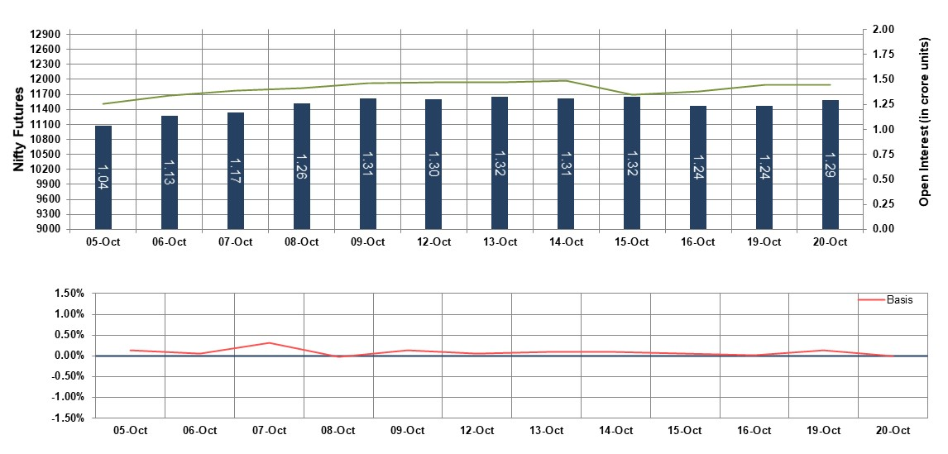
Bank Nifty Futures
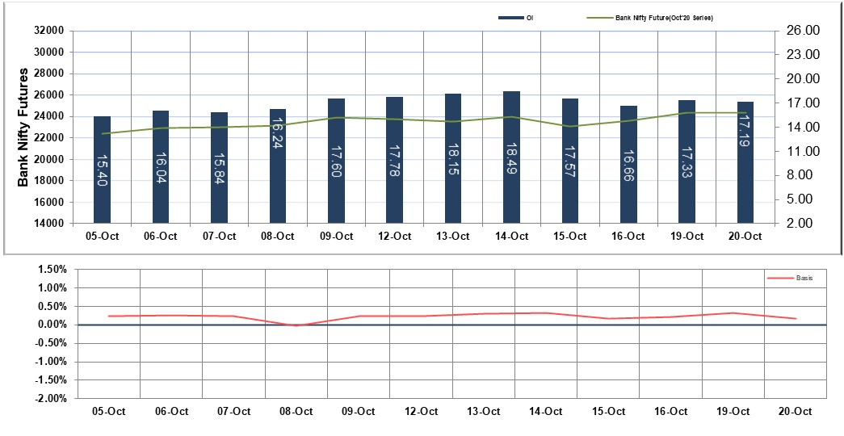

Nifty Options
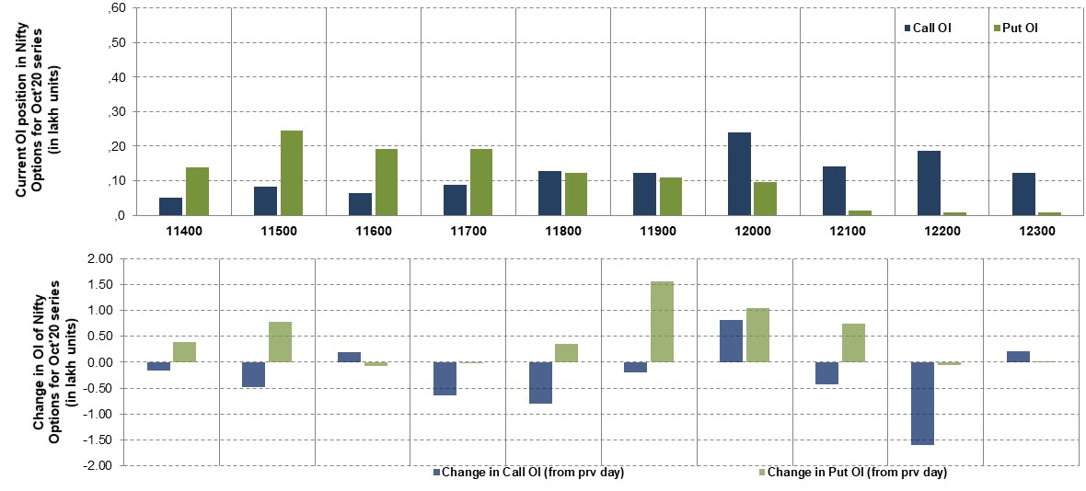
Note – Change in OI of Nifty Options refers to change from previous trading day
Source-NSE, SIHL Derivatives Research (Institutional Equities)
- Among Nifty calls 12,000 SP from the Oct month expiry was the most active call with an addition of 0.08 million in open interests.
- Among Nifty puts 11,500 SP from the Oct month expiry was the most active put with an addition of 0.08 million in open interests.
- The maximum OI outstanding for Calls was at 12,000 SP (2.39mn) and that for Puts was at 11,500 SP (2.45mn)
Nifty Technical & Indices Levels
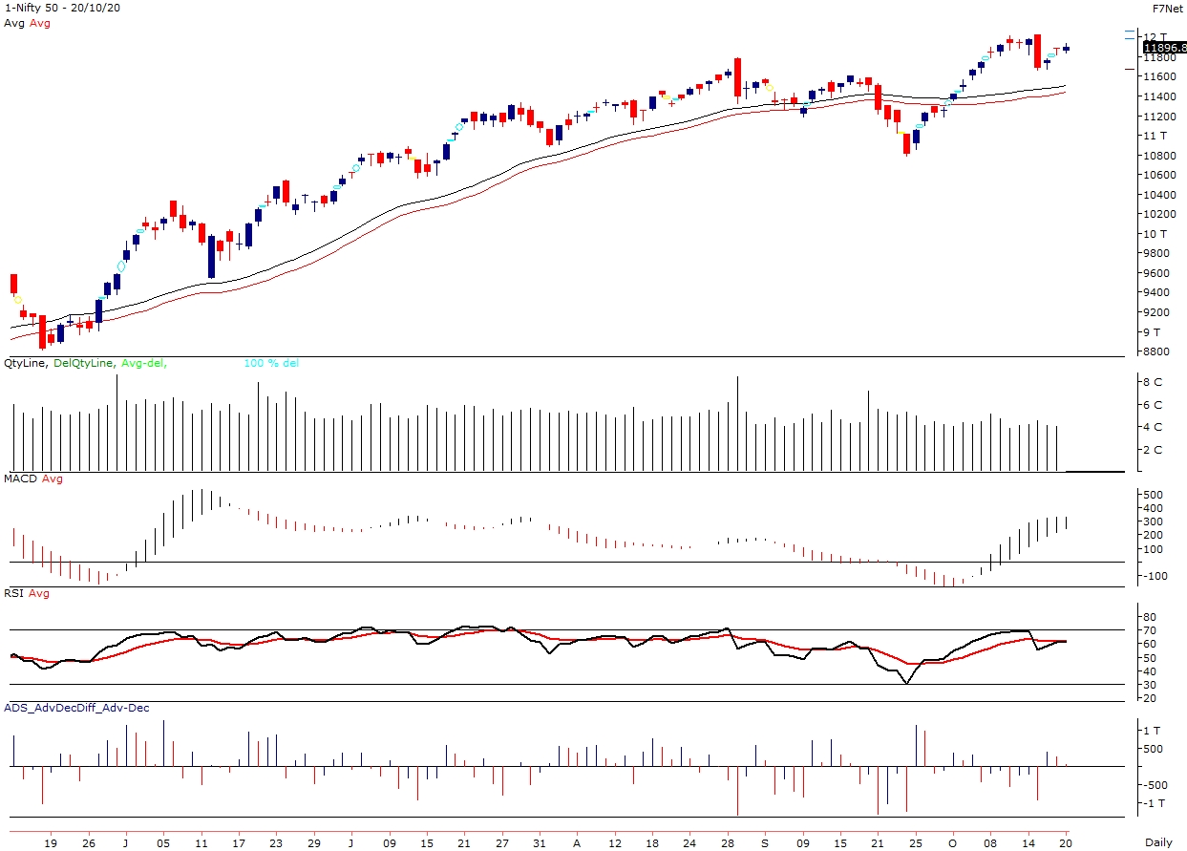
Nifty Cash prices have settled at 11896.80 up by 0.20 percent from the previous close. On the upper side it has resistance of 11970 and 12110 levels, while lower side it has support of 11770 and 11660 levels. Intraday traders should be cautious and take position accordingly.
Disclaimer:

The InformSation provided by SMS or in newsletter or in any document has been prepared by Shah Investor’s Home Ltd (SIHL). The Information provided by SMS or in newsletter does not constitute an offer or solicitation for the purchase or sale of any financial instrument or as an official confirmation of any transaction. The information contained herein is from publicly available data or other sources believed to be reliable, but we do not represent that it is accurate or complete and it should not be relied on as such. SIHL or any of its affiliates/ group companies shall not be in any way responsible for any loss or damage that may arise to any person from any inadvertent error in the information contained in this report or SMS. This Information provided by SMS, reports or in newsletter is provided for assistance only and is not intended to be and must not alone be taken as the basis for an investment decision. The user assumes the entire risk of any use made of this information. Each recipient of this Information provided by SMS, report or in newsletter should make such investigation as it deems necessary to arrive at an independent evaluation of an investment in the securities of companies referred to in this information provided by SMS, report or in newsletter (including the merits and risks involved), and should consult his own advisors to determine the merits and risks of such investment. The investment discussed or views expressed may not be suitable for all investors. This information is strictly confidential and is being furnished to you solely for your information.

The information should not be reproduced or redistributed or passed on directly or indirectly in any form to any other person or published, copied, in whole or in part, for any purpose. The information provided by report or SMS is not directed or intended for distribution to, or use by, any person or entity who is a citizen or resident of or located in any locality, state, country or other jurisdiction, where such distribution, publication, availability or use would be contrary to law, regulation or which would subject SIHL and affiliates/ group companies to any registration or licensing requirements within such jurisdiction. The distribution of this Information provided by SMS or in newsletter in certain jurisdictions may be restricted by law, and persons in whose possession this Information provided by SMS or in newsletter comes, should inform themselves about and observe, any such restrictions. The information given or Information provided by SMS, report or in newsletter is as of the date of the issue date of report or the date on which SMS provided and there can be no assurance that future results or events will be consistent with this information. This information is subject to change without any prior notice. SIHL reserves the right to make modifications and alterations to this statement as may be required from time to time. However, SIHL is under no obligation to update or keep the information current.

Nevertheless, SIHL is committed to providing independent and transparent recommendation to its client and would be happy to provide any information in response to specific client queries. Neither SIHL nor any of its affiliates, group companies, directors, employees, agents or representatives shall be liable for any damages whether direct, indirect, special or consequential including lost revenue or lost profits that may arise from or in connection with the use of the information. Past performance is not necessarily a guide to future performance. The disclosures of interest statements incorporated in the Information provided by SMS, report or in newsletter are provided solely to enhance the transparency and should not be treated as endorsement of the views expressed in the report. The analyst for this report certifies that all of the views expressed in this report accurately reflect his or her personal views about the subject company or companies and its or their securities, and no part of his or her compensation was, is or will be, directly or indirectly related to specific recommendations or views expressed in this report.

About Us:

Shah Investor’s Home Ltd (SIHL) is an ISO 9001:2008 Certified financial Services Company established in 1994 at Ahmadabad, Gujarat. Customer satisfaction is guaranteed through our diversified product portfolio, professional management and customer first attitude. SIHL was the first broking house in Gujarat with membership in National Securities Depository Ltd (NSDL) and was the first broking name providing services in NSE F&O in Ahmedabad. Today, SIHL ranks among the top most players in Gujarat in retail stock broking area with 45 branches, 350 franchisee across India and providing service to more than 1,25,000 clients.

